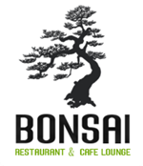

Invitation to Dinner

Japanese Degustation Evening
Contemporary authentic cuisine.

When: 6 PM on Sunday 30th October
Where: “The Bonsai”, 30 Roe St, Northbridge
Tickets: $85 p.p. – drinks provided
Booking: - Trybooking.com - The Bonsai
Join us for a fun evening of excellent food, surprises and prizes.
Hosted by the Dwellingup Discovery Forest Defenders. Proceeds to protecting the remaining native forests in the Darling Range. Our unique Jarrah forests are a global biodiversity hotspot.

