Minutes of the 20121 Annual General Meeting of
Nature Reserves Preservation Group (Inc.) of Kalamunda
6:30pm Wednesday 21 March 2022
Held upstairs at the Kalmaunda Hotel
43 Railway Rd, Kalamunda WA 6076

6:34pm Annual General Meeting commences
Steve Gates, current President, opened the AGM at, welcomed members & guest speaker Talithia Huston and acknowledged Noongar Country.
Attendees: Steve Gates, Margaret Fowler, Tony Fowler, Cathy Bredemayer, Brian Gould, Clive Stubbington, Daryl Saran, Eileen Stark, Margaret Dandson, Julie Scull, Holey Bradley, Michael Konrath, Ross Bernett, Cheryl Connolly, Lleyd Hatfield, Bruce Glover, Alan Evans, Carl Danzi, Penny Hussey, Sue Dowson, Phil Dowson, Mick Davis, Daryl McCarthey, Jane Wallis, Helen Carter, Kelsey Eldridge, Robin Hodgson, Talitha Huston, Ken Bredemeyer, Arthur Conacher, Jeanette Conacher
Apologies: Lynda Tomlinson, Kelsey Eldridge, Rhonda Hardy (CEO City of Kalamunda), David Broadhurst (City of Kalamunda), Michelle Taylor (City of Kalamunda), Tim Colegate, Rem van Santen, Di van Santen, Nola Boughton, Brett Boughton,

6:40pm Acceptance of 2021 AGM Minutes
Steve called for any changes from Members- none
- Moved Tony Fowler
- Seconded Jane Wallis
- Carried by majority

6:45pm Business arising from the Minutes
Steve asked for business arising
No business arising

6:50pm President’s Report
Steve Gates provided a report on the NRPG’s actions and activities since the last AGM. The full report is provided as Attachment 1
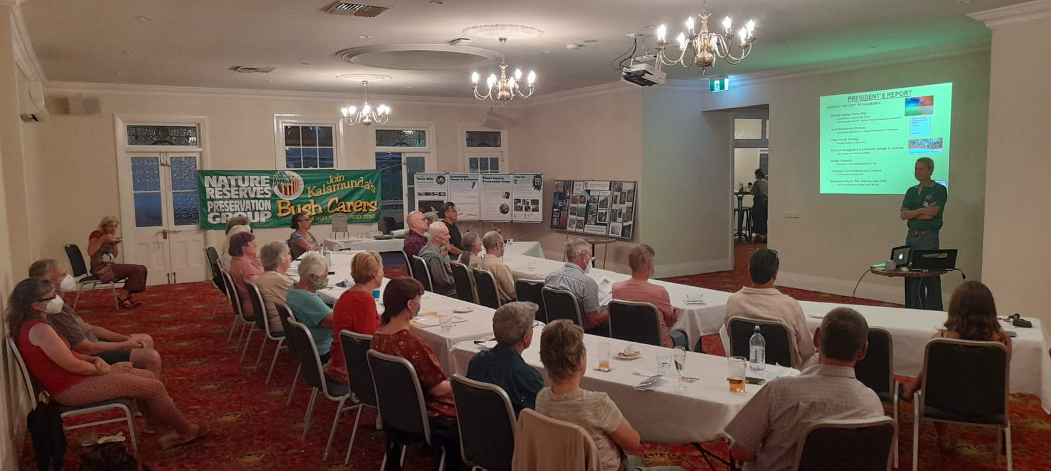
Steve Gates presenting the Presidents the Presidents Report to NRPG Inc. Members

7:10pm Treasurer’s Report
Cathy Bredemeyer provided a summary of the Financial Report and asked for any questions. No questions forthcoming.
Steve asked for the report to be accepted
- Move Bruce Glover
- Second Clive Stubbington
- Carried by majority
The full Treasurers report is provided as Attachment II at the end of the Minutes.

7:20pm Election of Executive Committee
Steve declared all positions Vacant and appointed Brian Gould as Returning Officer for the purposes of re-election of the Committee
As per the Constitution, nominations for executive and committee members were received prior to the meeting. With no competition for the following positions, members were elected unopposed:
- President: Steve Gates
- Vice President: vacant
- Treasurer: Cathy Bredemeyer
- Secretary: Mick Davis
Brian returned Steve as President of the NRPG Inc. and Steve continued proceedings
Steve asked members to consider nominating from the floor as Committee Members. No nominations were received.
Steve declared the following Committee Members:
Committee positions:
- Tony Fowler, Clive Stubbington, Brian Gould, Clive Stubbington, Kelsey Eldridge

7:12pm Guest Speaker - Talitha Huston
Talithi presented an educational and practical talk on some tips for photographing and attracting local birds, as well as discussion the origins and information within her new book “Birds of the Perth Hills”, of which a few copies were available for $25 for Members.

7:57pm General Business
Eileen Stark; enquired after information on the Maida Vale Bell (Blancoa caneacens) and any sightings of flowers. Eileen raised concerns about it’s decline locally and explained how she had been asking the City of Kalamunda and the Department of Biodiversity, Conservation and Attractions for further information.
Alan Evans; asked for any info on what's going on at Woodlupine Brook in regards to the work being done to stabilise and enhance the area between the shopping centres.

8:06pm Meeting Close
There being no further official business the AGM was closed by Steve Gates at 8:06pm and Members and guests were invites to stay to socialise

Appendices
I Presidents Report
II Treasurers Report

